Initials Program

# Author == Darren Isaacson  
# This program is designed to simplify their name into an abreviation.  
  
def main():  
 fullName = getName() # Gathers value  
 fullName = checkValidation(fullName) # Validates  
 splitName(fullName) # Output  
  
  
def getName():  
  
 name = input("Please enter in your full name here. Letters only!:") # Collects input  
 nameList = name.split() # Splits the list value  
  
 return nameList  
  
def checkValidation(fullName):  
  
 trueList = False # Base boolean  
 while not trueList:  
  
 for word in fullName:  
 if word.isalpha(): # If fullname does not have and numeric or special characters then truelist changes.  
 trueList = True  
 else: # If fullname has numeric or special characters then it sets trueList to be false and sends the user  
 # Call back the getName function.  
 trueList = False  
 newName = getName() # Gathers values  
 fullName = newName # Shares values of list  
 break  
 return fullName  
  
  
def splitName(fullName):  
 abbreviation = "" # Creates a base variable  
 for i in range(len(fullName)): # For every interation of the length of fullname (which is a list)  
 abbreviation += fullName[i][0].upper() + "." # Accumulates and adds a space  
  
 print("Your abbreviation is " + abbreviation)  
  
main()

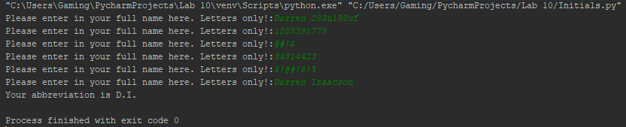

DigiSum Program

# Author == "Darren Isaacson"  
# This program is going to ask user for large integer.  
  
  
getNum = input("Enter you number: ") # Get the number  
  
while True: # Loops for input  
 if not getNum.isnumeric():  
 getNum = input("Enter you number using only numbers: ")  
 else:  
 break  
  
results = 0 # Base accumulator  
  
for i in range(len(getNum)):  
 results += int(getNum[i:i+1]) # Accumulates values for every number entered  
  
print("The numbers that you entered are %s and the results are %d" % (getNum, results))

